Revue Presse

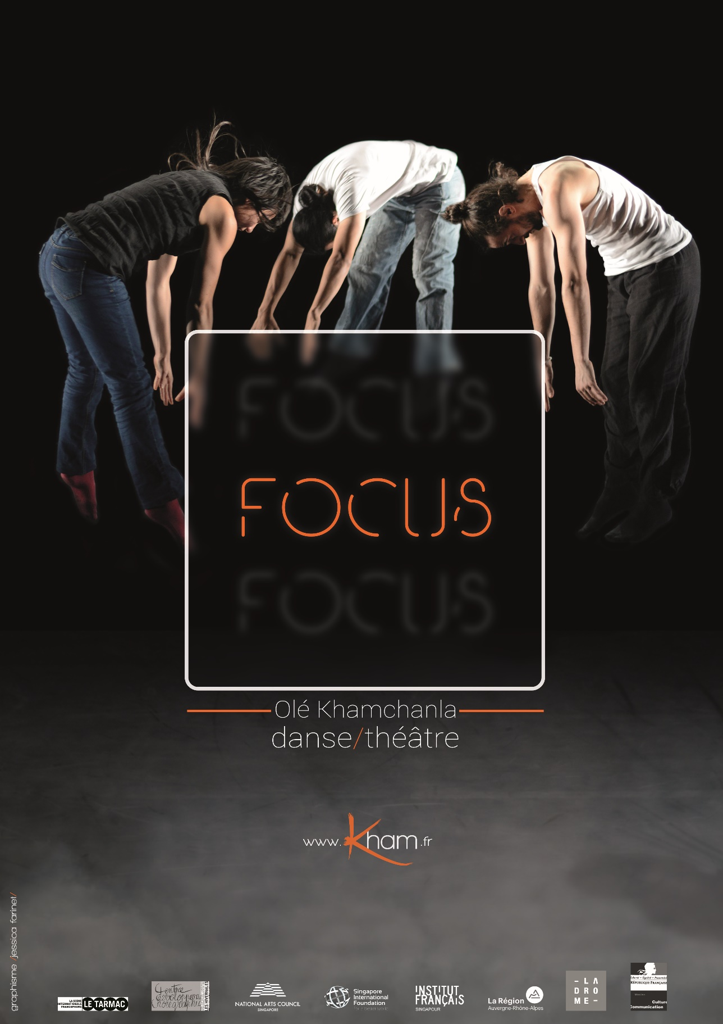

Quatrième édition du concours (Re)connaissance
La grande surprise est venue de la compagnie Kham avec Focus. Une pièce très écrite, une dramaturgie fort bien élaborée qui entremêle les différentes influences du danseur et chorégraphe Olé Khamchania qui vont du hip hop au Butô, des danses chinoises et indiennes aux styles traditionnels et contemporains. Un petit bijou qui a reçu le prix du CCAS, c’est à dire la signature d’un certain nombres de dates pour 2013.
Sophie Lesort, le 14/12/12
Source : http://toutelaculture.com

Olé Khamchanla est un mystère pour la danse… Danseur hors pair, il exécute avec une vélocité de félin des mouvements assez incroyables. Mêlant les techniques chorégraphiques qui nourrissent son imaginaire, il nous invite à vivre des moments uniques et forts.
J’ai eu la chance de le rencontrer grâce à Valérie Baran, directrice du Tarmac de Paris (ex TEP), qui le soutient depuis ses débuts et poursuit avec nous son compagnonnage. Olé Khamchanla est un artiste secret, réservé qui donne tout sur scène. Il prépare ce trio depuis des mois, multipliant les occasions de faire avancer sa danse et son projet à travers des ateliers et des voyages…

Emmanuel Serafini | Directeur du CDC des Hivernales d’Avignon

Focus by Compagnie Kham
Posted on 17 January, 2014
The start of the yearbrings a clean slate and the Necessary Stage has done exactly that with the M1 Fringe Festival 2014. For the pasttenyears, the local theatre company has based its festival around a major theme that links art to an aspect of society. In 2012, itwas Art and Faith; in 2011, itwas Art and Education. This year the theme of Art and the People explores the mostfundamentalrelationshipbetween art and the communitiesthatcreate and experienceit.
Against the festival’sthematicbackdrop, Laotian-French choreographer, Ole Khamchanla, willpresent a workentitled Focus. To bringthis composition to life, Khamchanla has roped in local dance artists Chan Sze Wei and Jereh Leong to perform in thiswork. It helpsthat Chan and Leong happen to betwo of Singapore’smostinterestingyoung dance artists. Some of youmayrememberChan’s performance, Do Gorillas Peel Bananas, at The Substation last year. Leong is a member of Frontier Danceland and isknown for the quirkypersonashe assumes in the company’sworks.
In thiswork, the threedancersmeet in a neutralspace and offerthemselvescandidly to the audience. The resultis a workthatishonest and organic in itsorigins. Focus shifts naturallybetween situations arisingfrom the wholeheartedinvolvement and interaction of the dancers.
“There weresomanyunknowns,” Chan recalled the initial meeting to discuss the work. Overcoming the earlyawkwardness of workingtogether for the first time, theygraduallyembraced the freedom to interpret and createthroughperforming and touring the work for the last twoyears.
Each section of the performance unfoldsclearly in space and draws the audience to alternating situations on stage. Lights serve only to highlightelementsthatdemandimmediate attention, directing the audience to focus on the precisemovements and gesturesunder the spotlight. The performers’ vastlydifferent backgrounds add to the choreography’seclecticism. Khamchanla’s break dancing background isevident as heisolates parts of his body withpinpointprecision. Ever the quirky one, Leong displays his vocal range as hesings and beatboxesinto a microphone. Chan matches the strength of the two male dancerswithhergroundedmovements and stoicpresence.
“Olewas the organiser, Sze the executor and I was the wild one,” said Leong. Whenasked how theymanaged to tietogethersuch a seemingly open endedpiece, Leong explainedthatitwasserendipitythat made everythingfallinto place. “Somehow I feltit all made senseevenwhenwewere a littleunsure. I wouldsuggestsomething, wewouldtryit and seewhat came of it.”
It wasn’talwayssmoothsailing, of course. Khamchanla, wholives in France, speakslittle English, leaving Chan to translate ideas to Leong from French. Despite the languagebarrier, the twoSingaporean performers relished the freedom to interpret the workaccording to theirownunderstanding. “We all benefittedfrom the space to makesomethingthat none of us hadeverseen or donebefore.” said Chan.
Focus by Compagnie Kham (France). Choreographed by Ole Khamchanla. Part of the M1 Fringe Festival 2014. 18-19 January 2014, 8pm, Esplanade Theatre Studio. Tickets available at SISTIC counters and online.

TEXT BY LEE MUN WAI

http://www.themuse.com.sg/2014/01/focus-by-compagnie-kham/

